Communication
Date | 15 July 2026
Team ID | SWTID-2026-2053
Project Name | OptiCrop: Smart Agricultural Production Optimization Engine
Maximum Marks | 1 Mark
Communication Plan:
S.No | Challenge Faced | Resolution / Action Taken
1 | Difficulty coordinating meetings due to different team members' schedules. | Created a fixed weekly meeting schedule and used a WhatsApp group for daily updates and task reminders.

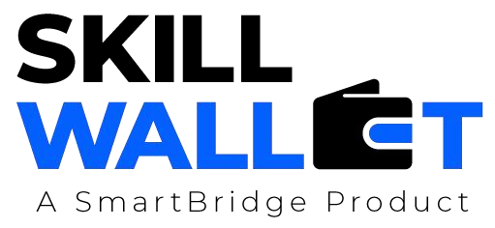
Effective communication is essential for a successful project demonstration. This document outlines the communication strategy used within the team and with stakeholders throughout the project lifecycle, including how updates, issues, and feedback were managed.
S.No | Communication Type | Frequency | Channel / Tool | Participants | Purpose
1 | Team Standup | Daily | Google Meet / WhatsApp Group | All 5 Team Members | Discuss daily tasks, assign work, and track project progress.
2 | Progress Update | Weekly | Microsoft Teams / Google Meet | Team Members &  Project Guide | Review weekly achievements, discuss milestones, and plan the next week's work.
3 | Issue / Bug Discussion | As Needed | WhatsApp / GitHub Issues | Developers & Team Members | Identify, discuss, and resolve software bugs and technical issues.
4 | Stakeholder Review | Bi-Weekly | Google Meet / Presentation | Team Members,  Project Guide &  Stakeholders | Demonstrate project progress, collect feedback, and discuss improvements.
5 | Final Demo Rehearsal | Once | College Lab / Google Meet | Entire Team & Project Guide | Practice the final project demonstration and ensure all features work correctly.
6 | Project Documentation Review | Weekly | Google Docs / Microsoft Word | Documentation  Lead & Team  Members | Review and update project documentation, reports, and presentation materials.
Communication Challenges & Resolutions:

2 | Miscommunication regarding task assignments and project progress. | Clearly assigned responsibilities to each team member and tracked progress using a shared task list and regular review meetings.
3 | Delays in resolving technical issues and integrating project modules. | Conducted bug discussion sessions, performed code reviews, and improved coordination between frontend, backend, and machine learning team members to ensure smooth integration.

